**Return on Investment (ROI) for Rain Prediction**

**using Neural Network Classification**

**What is Return on investment (ROI)**

Return on investment (ROI) is a mathematical formula used by investors to assess their investments and determine the performance of a particular investment compared to others. It is often utilised alongside other methods to build a business case for a proposed initiative. The overall ROI of a company serves as a measure of its management effectiveness.

ROI can assess various metrics, aiding in the determination of a business's profitability. For accurate ROI calculation, it is essential to measure total returns and costs. A positive ROI percentage indicates profitability for the business or the metric being evaluated. Conversely, a negative ROI percentage signifies that the business or the metric is incurring more costs than earnings. In essence, a positive percentage indicates that returns surpass total costs, while a negative percentage implies that the investment is resulting in a loss.

ROI is valuable for evaluating different investment decisions by comparing them against their initial costs. Businesses also rely on ROI calculations when assessing past or future investments. Individuals can use ROI to evaluate their investments and compare one investment, whether a stock holding or a financial stake in a small company, against another within their investment portfolios.

**Advantages and Disadvantages of ROI**

ROI is a universally used metric that allows for quick and easy evaluation and ranking of potential investments. Its simplicity makes it a preferred tool for comparing the returns of various investment options, such as real estate, stocks, bonds, or other businesses. Unlike more complex methods like the internal rate of return (IRR), the ROI is straightforward and can be calculated quickly. This makes it an invaluable tool for investors and financial analysts seeking to make informed decisions about where to allocate their resources.

ROI is a widely used financial metric to measure the profitability of an investment. However, it has some limitations that investors should be aware of. Firstly, the ROI does not take into account the impact of time. This can be addressed by using annualized ROI or IRR. Secondly, ROI does not consider the impact of leverage on cash flows and returns. To calculate this, investors can use "cash-on-cash return" or IRR. Thirdly, ROI does not account for the impact of capital appreciation.

In most cases, only ongoing cash flow is considered, and the impact of growth on the value of a business is ignored. Finally, ROI does not consider the value of potential. If two investments have similar rates of return, but one has higher potential, that investment may be more attractive. In summary, investors should be aware of these limitations and use other financial metrics in conjunction with ROI to make informed investment decisions.

In conclusion, it is important to approach ROI with a critical mindset and an understanding of its potential drawbacks. While it can provide valuable insights into the profitability and efficiency of an investment, it is not without its limitations. It is crucial to consider the specific goals and context of the analysis, as well as the potential biases and assumptions that may influence the results. With careful consideration and a clear understanding of its intended purpose, ROI can be a useful tool for making informed decisions in various business contexts, including purchasing, selling, and mergers and acquisitions.

**ROI Formula**

ROI can be calculated using two types of methods,

First method:

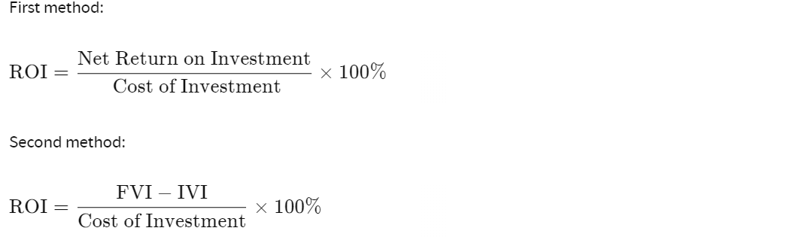

Second method:



Where that, 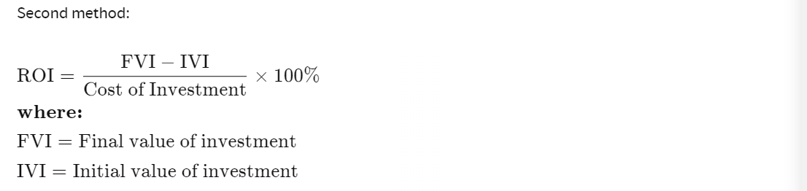

**ROI for Rain Prediction by Neural Network**

1. **Investment Components**:

Development Costs: $200,000

Data Acquisition and Preparation: $50,000

Model Development: $100,000

Resource Optimization: $30,000

Continuous Improvement: $20,000

Deployment: $40,000

**Total Investment (Cost of Investment): $440,000**

1. **Returns**:

Operational Optimization: $150,000 annually

Risk Mitigation: $80,000 annually

Increased Efficiency: $100,000 annually

Stakeholder Satisfaction: Intangible, difficult to quantify

**Total Annual Returns (Net Gain from Investment): $330,000**

